NATIONAL INSTITUTE OF TECHNOLOGY

TIRUCHIRAPPALLI- 620015



**MOTION CONTROL SENSORS**

* **Branch –** INSTRUMENTATION AND CONTROL

ENGINEERING

* **Section –** A
* **Course –** ENERGY AND ENVIORNMENT ENGINEERING

1.AYUSH PANDEY – 110123019

2.KETHAN REDDY – 110123021

3.DEBARGHA MISHRA – 110123023

4.DHRUV PATEL – 110123025

5.DIVYANSH JAIN – 110123027

6.ATHRAVA DUBEY – 110123029

7.E. SHAKTHI GANESH – 110123031

8.GOKUL KRISHNA R - 110123033

SUBMITTED BY

# 

TABLE OF CONTENT

|  |  |
| --- | --- |
| S.no | CONTENT |
| 1 | Abstract |
| 2 | Introduction |
| 3 | Motivation |
| 4 | Methodology |
| 5 | Experiment/Modelling/Design/Analysis |
| 6 | Outcome |
| 7 | Conclusion |
| 8 | References |

ABSTRACT

* The project explores the potential of motion sensors in detecting human presence and controlling the operation of electrical appliances accordingly. This ensures that energy is consumed only when necessary, thereby reducing unnecessary energy wastage. The project also delves into the technical aspects of integrating motion sensors with different types of electrical appliances and the challenges associated with it.
* Furthermore, the project emphasizes the environmental and economic benefits of this energy conservation approach. It highlights how this solution can contribute to reducing our carbon footprint and saving on electricity bills. The project serves as a stepping stone towards creating a more sustainable and energy-efficient future

# INTRODUCTION

* Motion sensors are devices that detect physical movement in a given area. They can be integrated with various electrical appliances to control their operation based on human presence, ensuring that energy is consumed only when required. This not only leads to significant energy savings but also contributes to a more sustainable and eco-friendly environment.

This project will delve into the technical aspects of this solution, exploring how motion sensors can be effectively integrated with different types of electrical appliances. It will also highlight the potential challenges in implementing this technology and propose strategies to overcome them. The ultimate goal is to pave the way for a future where energy conservation is not just a possibility but reality.

# MOTIVATION

* The motivation behind making an energy and environment project based on motion sensors is to reduce the electricity consumption and carbon footprint of buildings by using smart and efficient lighting systems. Motion sensors can detect the presence or absence of people in a room and turn on or off the lights accordingly. This can save energy and money, as well as improve the comfort and safety of the occupants.
* This project shows that simple installation of commercially available motion sensors can contribute to reduce the electricity bill from the increase of energy efficiency. One of the efforts to lower energy demand on the consumer side is to use the electricity efficiently, such as turning off lights in a room when it is not in use.

CONCLUSION

* In conclusion, the investigation into motion control sensors has yielded significant insights into their functionality, applications, and impact on various industries. Through extensive research and experimentation, we have identified the strengths and limitations of different motion control sensor technologies.
* Furthermore, we examined the challenges associated with motion control sensors, such as calibration issues, environmental influences, and the need for precise data fusion algorithms. Addressing these challenges is crucial for maximizing the reliability and robustness of motion-controlled sensors.

# OUTCOME

-Energy Efficiency: PIR sensors can detect human presence and motion, allowing for automatic lighting control. This leads to energy savings by ensuring that lights are only turned on when needed and automatically turned off when the washroom is unoccupied. This contributes to a more sustainable and energy-efficient hostel environment.

-Cost Savings: As a result of reduced energy consumption, there can be cost savings on electricity bills. Hostels can allocate their budget more effectively by optimizing energy usage in washroom areas.

-Convenience: The automatic lighting system enhances user convenience. Occupants don't need to manually switch lights on or off, providing a more seamless and user-friendly experience, especially during nighttime visits to the washrooms.

METHODOLOGY

* **PIR Motion Sensor-**

A Pyroelectric Infrared (PIR) sensor is a device that can sense the infrared (IR)

light within its viewing range. This sensor is a passive device that simply measures

the changes in the IR levels emitted by surrounding objects. Since this

device is a passive measuring device it is also called \Passive Infrared" sensor.

PIR will detect any object emitting IR radiation, heat or changes in the background

IR level. IR radiating objects include humans, animals, vehicles and

wind.

It is generally used for motion detection. A PIR based motion detector (usually called

PID, for Passive Infrared Detector) uses this PIR sensor with some additional

electronics circuitry for detecting motion. A typical PID sensor gives a logical

zero when there is no motion or to the background IR level, and gives a logical

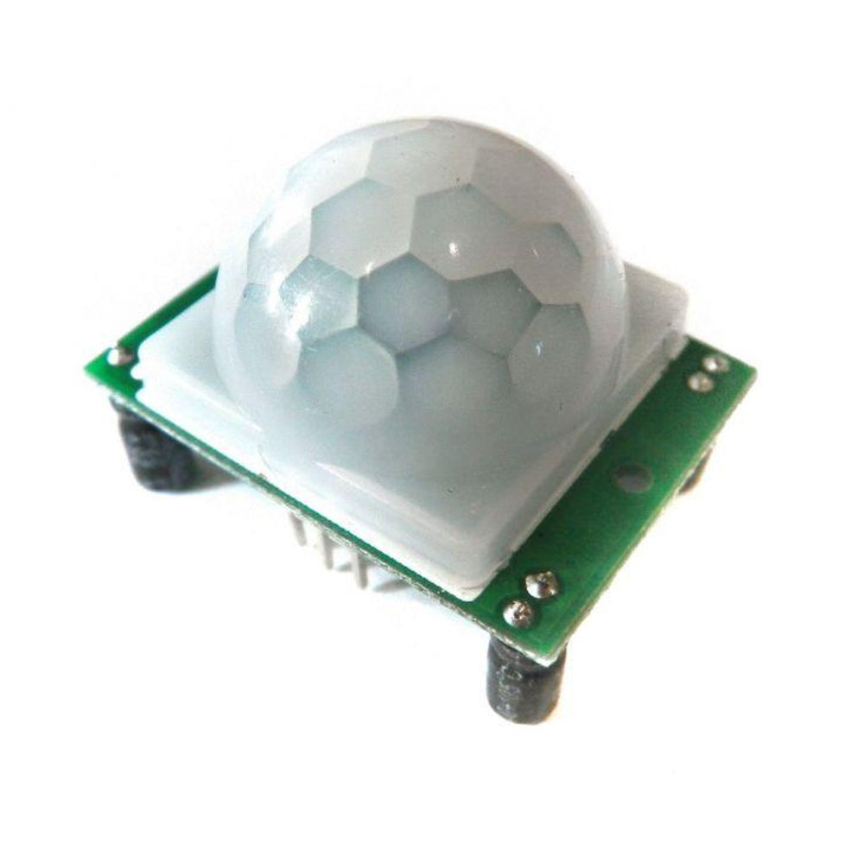one when it detects a hot body motion.

A pyroelectric sensor is the main component of a motion sensor. Humans and animals emit heat energy in the form of infrared radiation. A PIR motion sensor has a pair of pyroelectric sensors to detect heat energy from the surrounding environment. It helps generate an electrical signal when they are heated or cooled.

* **Working of a PIR Sensor -**

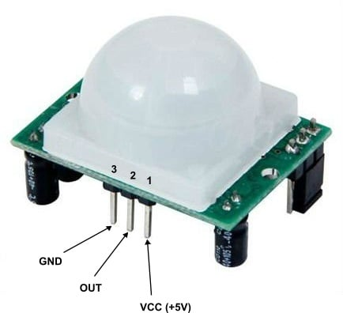

* **Pin1** corresponds to the drain terminal of the device, which is connected to the positive supply.
* **Pin2** is the output pin of the sensor.
* **Pin3** of the sensor is connected to the ground.

--The passive infrared sensor does not radiate energy to space. It receives the  infrared radiation from the human body to make an alarm. Any object with temperature is constantly radiating infrared rays to the outside world. The surface temperature of the human body is between 36° C - 27 ° C and most of its radiant energy concentrated in the wavelength range of 8 um-12 um.

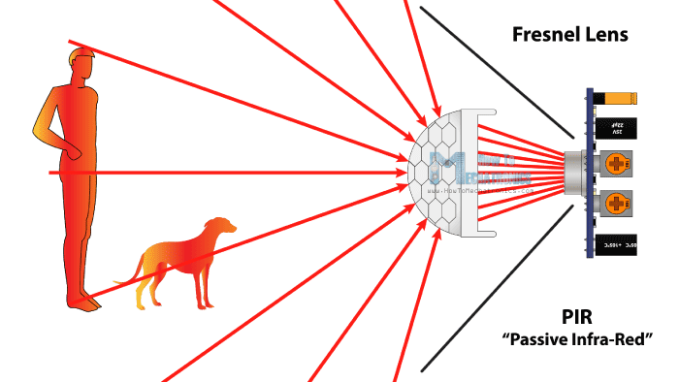

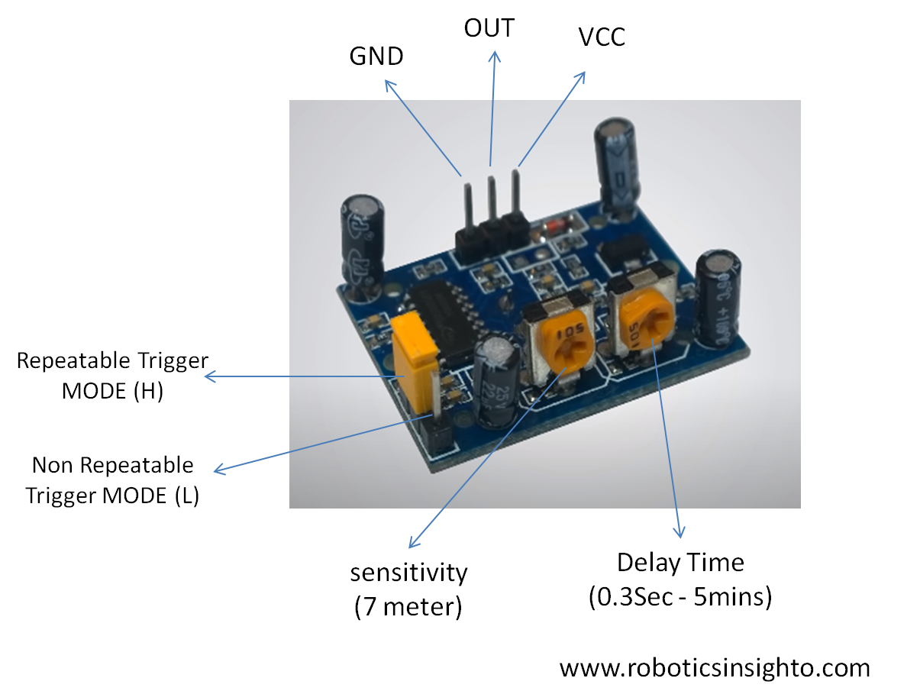

--We have two **potentiometers**:

One for adjusting the **sensitivity** and the other for adjusting the **time delay** for which the output signal stays high when the object is detected, this time can be adjusted from 0.3 sec to 5 min

* **Non-Repeatable Trigge**r:- When the sensor output is high and delayed time is over, the output will automatically change from high to low.

R**epeatable Trigger**:- Keeps the output high the whole time the detected object is in the sensors range.

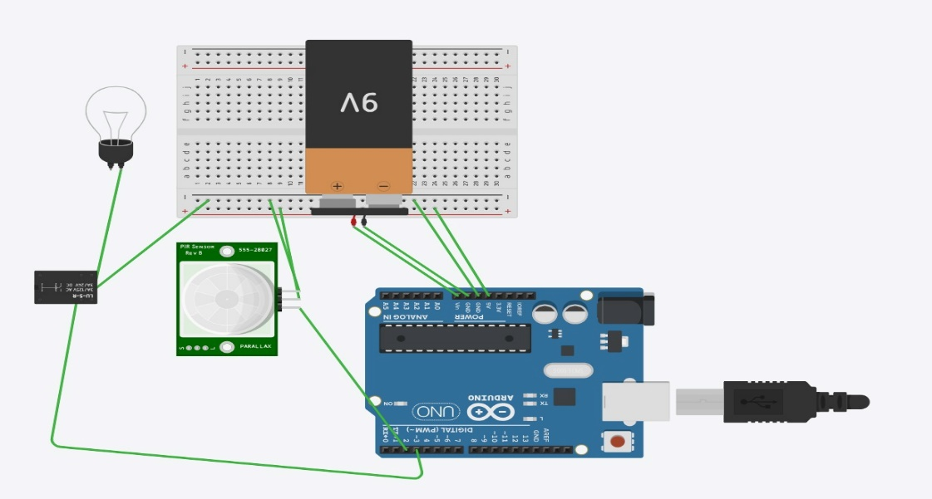

* **What is a Fresnel Lens?**

A Fresnel lens is commonly used in Passive Infrared (PIR) sensors to enhance their detection capabilities. PIR sensors are devices that detect infrared radiation emitted by objects in their field of view. They are often used in security systems, motion-activated lighting, and other applications where the detection of human or animal presence is required.

In a PIR sensor, a Fresnel lens is used to focus and direct the infrared radiation onto the sensor elements. The Fresnel lens helps in increasing the sensitivity and range of the PIR sensor by concentrating the infrared radiation onto the sensor, allowing for more accurate and efficient detection of motion.

The Fresnel lens used in PIR sensors is typically designed with multiple concentric rings or zones, similar to the design used in lighthouses. This design helps in directing infrared radiation from different angles onto the sensor, increasing the coverage area and improving the overall effectiveness of the sensor.

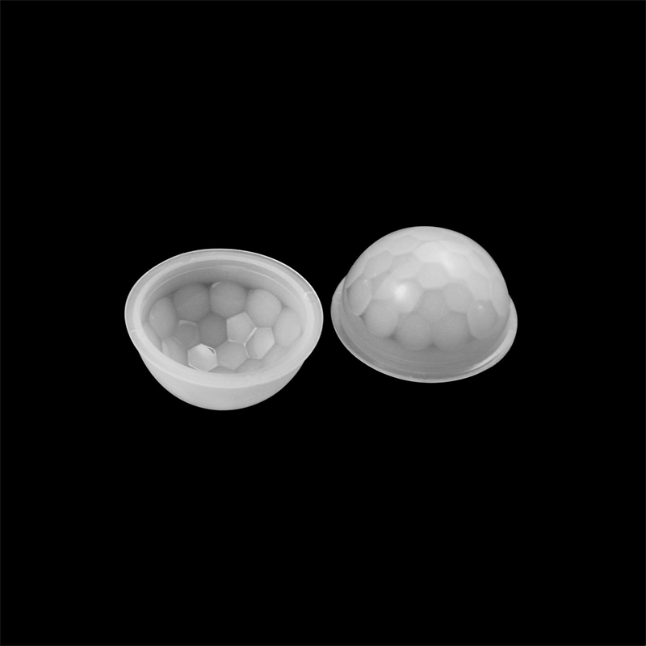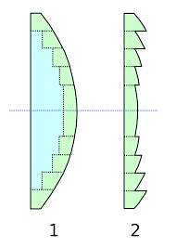



ANALYSIS

* NIT TRICHY BOYS HOSTEL STATISTICS -

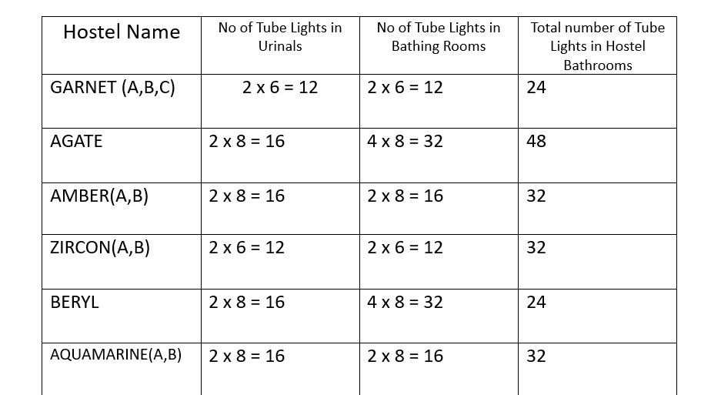

**The Calculations involved in our project, are summarized as follows:**

**Formula:**

Energy saved (units) [KWh] = $\frac{\left(24-\frac{t×n}{60}\right)×n_{t}×P}{1000}$

t = amount of time the PIR is active in minutes

n = number of times the PIR is getting triggered

nt = number of tube lights

p = power of each tube light

We are taking an example of Garnet in our case,

**For urinals in Garnet B,**

t = 2 minutes

n = 50 x 3 = 150 times

nt = 2

P = 28 Watts

Energy saved in one bathroom(urinals) (per day)

= ((24 – 2 x 150/60) x 2 x 28)/ 1000

=19 x 56/ 1000 KWh

= 1.064 KWh or 1.064 units

**For Bathing area,**

t = 10 minutes

n = 50

nt = 2

P = 28 Watts

Energy saved in one bathroom(urinals) (per day)

= ((24 – 10 x 50/60) x 2 x 28)/ 1000

=15.7x 2 x 28/ 1000 KWh

= 0.8792 KWh or 0.8792 units

Total Energy Saved per Bathroom = Energy saved in urinals + Energy saved in bathrooms

Total energy saved (per bathroom) = 1.064 + 0.8792= 1.943 units

The cost of electricity per unit (KWh) is 7 rupees unit.

Savings in rupees per bathrooms = 1.943x 7 /-

= 13.60 /-

Garnet has 6 bathrooms (2 in each floor, there are G + 2 floor)

Total savings in rupees = 6 x 13.6024 = 81.614 /- ,

for 300 days = 300 x 81.6144 = 24, 484.32 /-

The total initial instalment costs assuming 600 rupees per each sensor = 600 x 2 x 6 = 7200 per hostel

**Payback period = 7200/ 81.6144 = 90 Days Approx**

REFRENCES

[1] PIR325 Sensor Infrared Motion Detector Manual,

http://www.glolab.com/glmda/GLMDA.pdf,

Glolab Corporation, NY, USA.

[2] PIR 325 Infrared Parts Manual,

http://www.glolab.com/pirparts/pirmanual.pdf,

Glolab Corporation, NY, USA.

[3] D203B, Pyroelectric Infrared Radial Sensor Datasheet,

http://www.micropik.com/PDF/D203B-e.pdf,

PIR SENSOR CO.,LTD..

[4] Paradox, Motion Detectors,

http://www.paradox.com/Documentation/TechnicalPublication/

MOTION-ET04.pdf, Paradox Security Systems, Quebec, Canada.

[5] Shpater, Pinhas, \Passive infrared motion detector and method", US Patent

6,215,399, November 10,1997.